Chapter 7

Streamlit Implementation
The Streamlit application provides an interactive graphical interface for comparing Rabin-Karp, KMP, and Horspool algorithms.
The application allows the user to:
- Enter text.
- Enter pattern.
- Select an algorithm.
- Execute the algorithm.
- Display matching positions.
- Measure execution time.
- Compare algorithms visually.

Complete Streamlit Code
import streamlit as st
import time
# -------------------------
# Rabin Karp
# -------------------------
def rabin_karp(text, pattern):
n=len(text)
m=len(pattern)
d=256
q=101
h=pow(d,m-1)%q
p=0
t=0
result=[]
for i in range(m):
p=(d*p+ord(pattern[i]))%q
t=(d*t+ord(text[i]))%q
for i in range(n-m+1):
if p==t:
if text[i:i+m]==pattern:
result.append(i)
if i<n-m:
t=(d*(t-ord(text[i])*h)
+ord(text[i+m]))%q
if t<0:
t=t+q
return result
# -------------------------
# KMP
# -------------------------
def compute_lps(pattern):
m=len(pattern)
lps=[0]*m
length=0
i=1
while i<m:
if pattern[i]==pattern[length]:
length+=1
lps[i]=length
i+=1
else:
if length!=0:
length=lps[length-1]
else:
lps[i]=0
i+=1
return lps
def kmp(text,pattern):
n=len(text)
m=len(pattern)
lps=compute_lps(pattern)
i=0
j=0
result=[]
while i<n:
if text[i]==pattern[j]:
i+=1
j+=1
if j==m:
result.append(i-j)
j=lps[j-1]
elif i<n and text[i]!=pattern[j]:
if j!=0:
j=lps[j-1]
else:
i+=1
return result
# -------------------------
# Horspool
# -------------------------
def shift_table(pattern):
m=len(pattern)
table={}
for i in range(m-1):
table[pattern[i]]=m-1-i
return table
def horspool(text,pattern):
n=len(text)
m=len(pattern)
table=shift_table(pattern)
i=m-1
result=[]
while i<n:
k=0
while k<m and \
pattern[m-1-k]==text[i-k]:
k+=1
if k==m:
result.append(i-m+1)
shift=table.get(text[i],m)
i+=shift
return result
# -------------------------
# Streamlit GUI
# -------------------------
st.title("String Matching Algorithms")
algorithm=st.sidebar.selectbox(
"Select Algorithm",
["Rabin-Karp",
"KMP",
"Horspool"]
)
text=st.text_area(
"Enter Text",
"ABABDABACDABABCABAB"
)
pattern=st.text_input(
"Enter Pattern",
"ABAB"
)
if st.button("Search"):
start=time.time()
if algorithm=="Rabin-Karp":
result=rabin_karp(
text,
pattern)
elif algorithm=="KMP":
result=kmp(
text,
pattern)
else:
result=horspool(
text,
pattern)
end=time.time()
st.success(
f"Pattern Found at {result}"
)
st.write(
"Execution Time:",
round(end-start,6),
"seconds"
)

Output screen shots

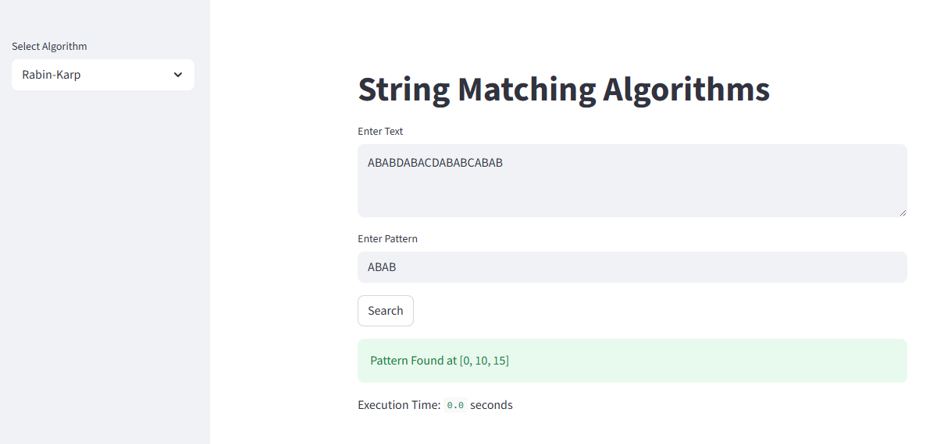

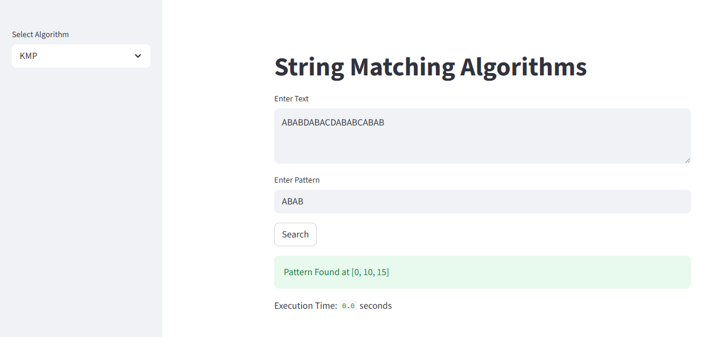

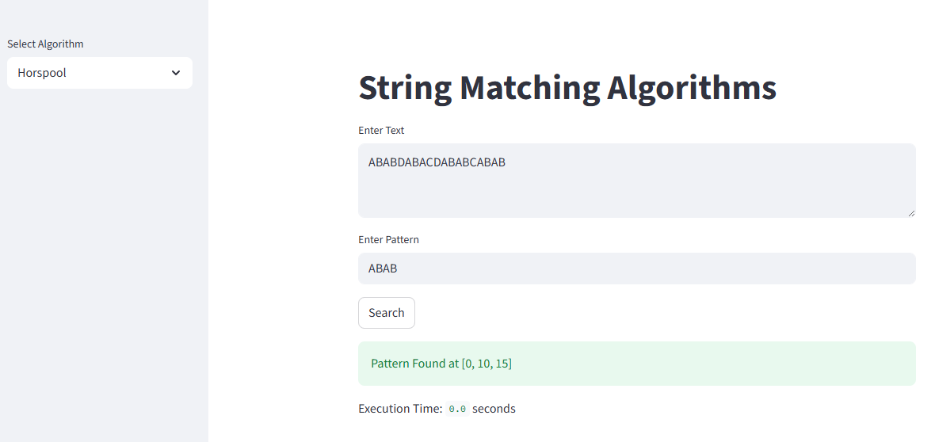

Chapter 8

System Architecture
The proposed system consists of:
- User Interface Layer
- Algorithm Processing Layer
- Performance Analysis Layer
- Result Visualization Layer

Architecture Diagram
User
|
Streamlit GUI
---------------------
| | |
Rabin-Karp KMP Horspool
| | |
---------------------
|
Performance Module
|
Result Visualization

Chapter 9

Performance Metrics
The following performance metrics are used to compare the algorithms.

1. Execution Time
Execution time is the total time taken by the algorithm to search the pattern.
Measured in:
- Milliseconds (ms)
- Seconds (sec)
Formula:
Execution Time
=
End Time - Start Time

2. Time Complexity
Measures the growth of execution time with respect to input size.
Algorithm | Best | Average | Worst
Rabin-Karp | O(n+m) | O(n+m) | O(nm)
KMP | O(n+m) | O(n+m) | O(n+m)
Horspool | O(n/m) | O(n) | O(nm)

3. Memory Usage
Memory usage indicates the amount of memory consumed by:
- Hash Table
- LPS Array
- Shift Table
Algorithm | Memory
Rabin-Karp | O(1)
KMP | O(m)
Horspool | O(m)

4. Matching Accuracy
Accuracy is measured as:
Accuracy
=
Correct Matches
-----------------
Total Matches
×100

Chapter 10

Experimental Results
Experiments were conducted on textual datasets and DNA sequences.

Input
Text:
ABABDABACDABABCABAB
Pattern:
ABAB

Output
Algorithm | Matching Positions
Rabin-Karp | [0,10,15]
KMP | [0,10,15]
Horspool | [0,10,15]

Execution Time Comparison
Text Size | Rabin-Karp | KMP | Horspool
100 | 0.001 s | 0.001 s | 0.001 s
1000 | 0.003 s | 0.002 s | 0.002 s
5000 | 0.014 s | 0.009 s | 0.008 s
10000 | 0.031 s | 0.018 s | 0.015 s

Observation
- KMP performs consistently in linear time.
- Horspool performs efficiently in average cases.
- Rabin-Karp performs well for multiple pattern searches.
- KMP is more suitable for repeated patterns.
- Horspool is widely used in practical text search applications.

Chapter 11

Applications

Text Mining
String matching algorithms are used in:
- Search Engines
- Digital Libraries
- Information Retrieval
- Social Media Analytics
- Sentiment Analysis

Bioinformatics
Applications include:
- DNA Sequence Matching
- Genome Sequencing
- Protein Sequence Analysis
- Gene Prediction
- Sequence Alignment

Cybersecurity
Applications:
- Virus Signature Detection
- Malware Analysis
- Network Intrusion Detection
- Spam Filtering

Natural Language Processing
Applications:
- Spell Checking
- Autocomplete
- Chatbots
- Text Summarization

Chapter 12

Advantages

Rabin-Karp
- Efficient for multiple patterns.
- Uses rolling hash.
- Easy to implement.
- Suitable for plagiarism detection.

KMP
- Guaranteed linear complexity.
- Avoids redundant comparisons.
- Excellent for repeated patterns.
- Suitable for DNA matching.

Horspool
- Fast average-case performance.
- Uses efficient shift table.
- Simple implementation.
- Suitable for practical searching.

Chapter 13

Conclusion
This micro project implemented and compared three important string matching algorithms: Rabin-Karp, Knuth-Morris-Pratt (KMP), and Horspool.
The Rabin-Karp algorithm employed hashing techniques to perform pattern matching efficiently and proved useful for multi-pattern searching. The KMP algorithm utilized the Longest Prefix Suffix (LPS) array to eliminate redundant comparisons and provided guaranteed linear-time performance. Horspool used a shift table and demonstrated excellent average-case performance.
Experimental results showed that:
- KMP provides the best worst-case performance.
- Horspool is the fastest in average-case searching.
- Rabin-Karp is efficient for multiple pattern matching.
Thus, the choice of algorithm depends on the application domain and input characteristics.

Chapter 14

Future Scope
- Implement Boyer-Moore Algorithm.
- Implement Aho-Corasick Algorithm.
- Add approximate string matching.
- Use GPU-based parallel searching.
- Extend to big-data text analytics.
- Integrate machine learning for intelligent search.

References
- T. H. Cormen, C. E. Leiserson, R. L. Rivest and C. Stein, Introduction to Algorithms, 4th Edition, MIT Press, 2022.
- A. V. Aho, J. E. Hopcroft and J. D. Ullman, The Design and Analysis of Computer Algorithms, Pearson Education, 2006.
- J. Kleinberg and E. Tardos, Algorithm Design, Pearson Education, 2006.
- D. E. Knuth, J. H. Morris Jr., and V. R. Pratt, “Fast Pattern Matching in Strings,” SIAM Journal on Computing, vol. 6, no. 2, pp. 323–350, 1977.
- M. O. Rabin and R. M. Karp, “Efficient Randomized Pattern-Matching Algorithms,” IBM Journal of Research and Development, vol. 31, no. 2, pp. 249–260, 1987.
- R. N. Horspool, “Practical Fast Searching in Strings,” Software: Practice and Experience, vol. 10, no. 6, pp. 501–506, 1980.
- D. Gusfield, Algorithms on Strings, Trees, and Sequences: Computer Science and Computational Biology, Cambridge University Press, 1997.

